=========================***PROGRAM DOCUMENTATION***=======================

**Leader:** Darben Lamonte

**Members:**

Shanella Cagulang

Miyuki Parocha

Althea Amor J. Asis

Gerard Cuadra

**Year & Section:** BSIT 1-2

**COLOR CODE**:

Blue Highlight = Comments

Green Highlight = Functions

Yellow highlight = Explanation

Red highlight = Preparation

Magenta highlight = Variable

Violet highlight = Process/Formula

Gray highlight = Sample output

**RUBRICS:**

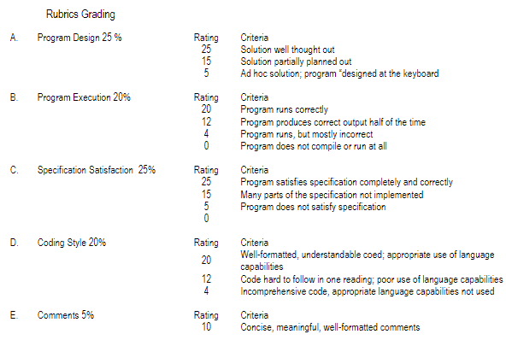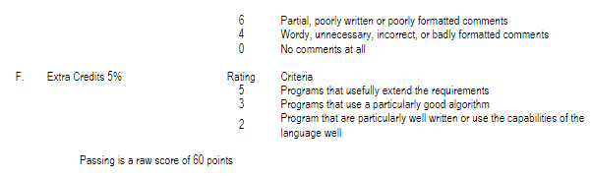

=============================***PROBLEM NUMBER 1:***=========================

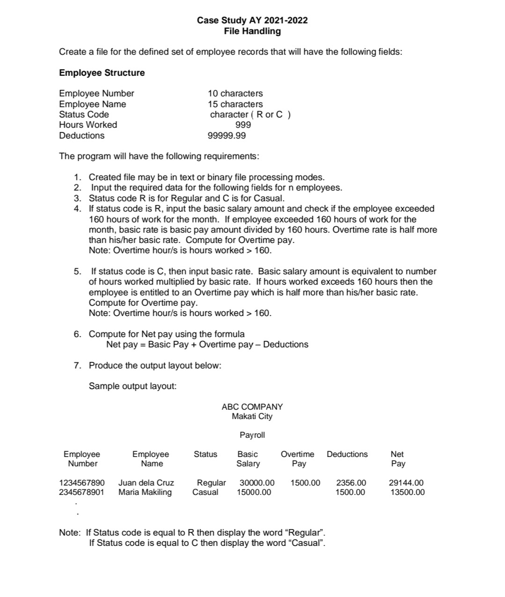

**PRINT OUTPUT:**



VARIABLES:

char empname[15]; // employee name

char empnum[10]; // employee number

char statcode[8]; // status code

int hrswork; // hours worked

double bsalary; // basic salary

double brate; // basic rate

double halfbrate; // half of basic rate

double otpay; // overtime pay

double othours; // overtime hours

double otrate; // overtime rate

double netpay; // net pay

double deduc; // deduction

FUNCTIONS:

int ValidName(cons char* name); // function to check if the name input is letters only

void input(); // function to input employees data

void otcompu(); // function to compute overtime pay

void regular(); // function for regular employee

void casual(); // function for casual employee

void create(); // function to create the "txt" file or write to the file

void display(); // function to display the data written to the file

void append(); // function to append the records to the file

**PROGRAM REQUIREMENTS:**

1. Created file may be in text or binary file processing modes.

***Solution:*** We create file in text processing mode. We use "fptr = fopen("employee.txt", "w");" to create or write to the file, and "fptr = fopen("employee.txt", "a");" to append records to the file.

2. Input the required data for the following fields for n employees.

***Solution:*** We utilize the input(); function.

3. Status code R is for Regular and C is for Casual.

***Solution:*** In order to display the word “Regular” and “Casual”, we use a predefined function strcpy, which copies the word “Regular” if ‘R’ is selected, and the word “Casual” if “C” is selected.

If (status code == ‘R’) {

strcpy(status code, “Regular”);

}

else if (status code == ‘C’) {

strcpy(status code, “Casual”);

}

4. If status code is R, input the basic salary amount and check if the employee exceeded

160 hours of work for the month. If employee exceeded 160 hours of work for the

month, basic rate is basic pay amount divided by 160 hours. Overtime rate is half more

than his/her basic rate. Compute for Overtime pay.

Note: Overtime hour/s is hours worked > 160.

***Solution:***

if (status code == R) {

input basic salary

if (hours worked > 160) {

basic rate = basic salary / 160

half basic rate = basic rate / 2

overtime rate = basic rate + half basic rate

overtime hours = hours worked - 160

overtime pay = overtime rate * overtime hours

}

else {

just display the basic salary

}

}

5. If status code is C, then input basic rate. Basic salary amount is equivalent to number

of hours worked multiplied by basic rate. If hours worked exceeds 160 hours then the

employee is entitled to an Overtime pay which is half more than his/her basic rate.

Compute for Overtime pay.

Note: Overtime hour/s is hours worked > 160.

***Solution:***

if (status code == C) {

input basic rate

basic salary = basic rate * hours worked

if (hours worked > 160) {

half basic rate = basic rate / 2

overtime rate = basic rate + half basic rate

overtime hours = hours worked - 160

overtime pay = overtime rate * overtime hours

}

else {

just display the basic salary

}

}

6. Compute for Net pay using the formula

Net pay = Basic Pay + Overtime pay – Deductions

7. Produce the output layout below:

**CODE NO1 (*explanation)*:**

**Code Link:** <https://drive.google.com/file/d/1UxLPI5jEDPcpswI1DKovg1JzFgnzswhy/view?usp=drive_link>

/* These are the standard header files included in the code. They provide necessary functions for input/output operations, string manipulation, memory allocation, and character handling.*/

#include <stdio.h>

#include <stdlib.h>

#include <string.h>

#include <conio.h>

#include <ctype.h>

/* Here, the variables number and i are declared to store the number of employees and as a loop counter, respectively. fptr is a file pointer used for file operations. */

int number, i;

FILE* fptr;

/* This code defines a structure called employee that represents the attributes of an employee. It contains fields such as employee name, number, status code, hours worked, basic salary, basec rate, half of basic rate and rates for overtime pay, net pay, and deductions. */

struct employee {

char empname[15];

char empnum[10];

char statcode[8];

int hrswork;

double bsalary;

double brate;

double halfbrate;

double otpay;

double othours;

double otrate;

double netpay;

double deduc;

};

struct employee emprec[100]; // Array to store employee records

An array of type employee is declared with a size of 100 to store employee records.

/* This is a function named ValidName that checks if a given name contains only alphabetic characters. It returns 1 if the name is valid and 0 otherwise. */

int ValidName(const char* name) {

for (int i = 0; name[i] != '\0'; i++) {

if (isdigit(name[i])) {

return 0;

}

}

return 1;

}

/* This function input is used to gather employee information from the user. It prompts the user to enter the employee number, name, hours worked, and deductions. It also validates the name using the ValidName function. */

void input() {

printf("\n\tEnter employee number: ");

scanf("%s", emprec[i].empnum);

again:

printf("\n\tEnter employee name: ");

scanf("\n");

scanf("%[^\n]s", emprec[i].empname);

int validName = 0;

if (!ValidName(emprec[i].empname)) { // checks if the name does not contain numbers

printf("\n\tInvalid employee name!\n\tOnly alphabetic characters are allowed.\n");

goto again;

} else {

validName = 1; // allowing the program to move forward

}

printf("\n\tHours Worked: ");

scanf("%d", &emprec[i].hrswork);

printf("\n\tDeductions: ");

scanf("%lf", &emprec[i].deduc);

printf("\n\tStatus Code [R/C]: %s ", emprec[i].statcode);

}

/* The otcompu function calculates overtime pay for an employee. It computes the overtime rate, overtime hours, and overtime pay based on the basic rate and hours worked. */

void otcompu() {

emprec[i].halfbrate = emprec[i].brate / 2;

emprec[i].otrate = emprec[i].brate + emprec[i].halfbrate;

emprec[i].othours = emprec[i].hrswork - 160;

emprec[i].otpay = emprec[i].otrate * emprec[i].othours;

}

/* The regular function is used to gather additional information for regular employees. It calls the input function to get common employee details and then prompts the user to enter the basic salary. If the employee worked more than 160 hours, it calculates the overtime pay by dividing the basic salary by 160 and calls otcompu to compute the overtime-related attributes. */

void regular() {

input();

printf("\n\n\tEnter Basic Salary: ");

scanf("%lf", &emprec[i].bsalary);

if (emprec[i].hrswork > 160) {

printf("\n\n\tThe employee is entitled to OVERTIME PAY!\n");

emprec[i].brate = emprec[i].bsalary / 160;

otcompu();

}

}

/* The casual function is similar to regular but is used for casual employees. It gathers common employee details using the input function and then prompts the user to enter the basic rate. If the employee worked more than 160 hours, it calculates the overtime pay by calling otcompu. */

void casual() {

input();

printf("\n\n\tEnter Basic Rate: ");

scanf("%lf", &emprec[i].brate);

emprec[i].bsalary = emprec[i].brate * emprec[i].hrswork;

if (emprec[i].hrswork > 160) {

printf("\n\tThe employee is entitled to OVERTIME PAY!\n");

otcompu();

}

}

/* The create function is responsible for creating a new file to store employee records. It prompts the user to enter the number of employees and the status code (regular or casual) for each employee. Based on the status code, it calls regular or casual to gather the specific employee information. The employee records are then written to the file "employ.txt" using the fprintf function. */

void create() {

char sc;

int ex;

fptr = fopen("employ.txt", "w"); // Open file in write mode

system("cls");

if (fptr == NULL) {

printf("\n\t[File cannot be created!]");

exit(1);

}

do {

printf("\n\t==========[\033[32mYOU ARE CREATING\033[0m]==========\n");

printf("\n\tEnter the number of employees you will input: ");

scanf("%d", &number);

if (number <= 0) {

printf("\n\tInvalid input! Please enter a positive number.\n");

fflush(stdin);

}

} while (number <= 0);

printf("\n\t==========[STATUS CODE]=========");

printf("\n\t| |");

printf("\n\t| [ R ] - Regular |");

printf("\n\t| [ C ] - Casual |");

printf("\n\t| |");

printf("\n\t================================\n");

fprintf(fptr, "\n\t\tABC COMPANY\n");

fprintf(fptr, "\t\tMakati City\n");

fprintf(fptr, "\n\t\tPayroll\n\n");

fprintf(fptr, "\n\t %15s\t%15s\t%15s\t%15s\t%15s\t%15s\t%15s \n", "Employee Number", "Employee Name", "Status Code", "Basic Salary", "Overtime Pay", "Deductions", "Net Pay" );

for (i = 0; i < number; i++) {

ex = 0;

while (ex == 0) {

again:

printf("\n\t[Enter status code of employee \033[32m %d \033[0m (R/C)]: ", i + 1);

scanf(" %c", &sc);

switch (sc) {

case 'R':

case 'r':

strcpy(emprec[i].statcode, "Regular");

regular();

ex = 1;

break;

case 'C':

case 'c':

strcpy(emprec[i].statcode, "Casual");

casual();

ex = 1;

break;

default:

printf("\n\t[Invalid Input!]\n\tEnter R or C only! Press any key to continue...");

getch();

printf("\n");

goto again;

break;

}

}

emprec[i].netpay = emprec[i].bsalary + emprec[i].otpay - emprec[i].deduc;

fprintf(fptr, "\n\t%13s\t%17s\t%12s\t%12.2lf\t%10.2lf\t%13.2lf\t%15.2lf", emprec[i].empnum, emprec[i].empname, emprec[i].statcode, emprec[i].bsalary, emprec[i].otpay, emprec[i].deduc, emprec[i].netpay);

}

fclose(fptr); // Close the file

printf("\n\n\t==========[You have successfully created employees' record!]=========");

printf("\n\tPress any key to return to the main menu...");

getch();

return;

}

/* The display function is used to read and display employee records from the file "employ.txt". It opens the file in read mode and reads the content line by line using fgets. The employee records are printed on the console after skipping some initial lines. */

void display() {

fptr = fopen("employ.txt", "r"); // Open file in read mode

system("cls");

if (fptr == NULL) {

printf("\n\t[File does not exist!]");

exit(1);

}

printf("\n\t=========================================================[ \033[33mABC COMPANY\033[0m ]===========================================================");

printf("\n\t| \033[33mMakati City\033[0m |");

printf("\n\t| \033[33mPayroll\033[0m |");

printf("\n\t===================================================================================================================================\n");

char line[150];

int skipLines = 6; // Number of lines to skip before printing employee records

while (fgets(line, sizeof(line), fptr) != NULL) {

// Skip the lines containing ABC COMPANY, Makati City, and Payroll

if (skipLines > 0) {

skipLines--;

continue;

}

// Trim leading and trailing whitespace

char* trimmedLine = line;

size_t len = strlen(trimmedLine);

if (len > 0 && trimmedLine[len - 1] == '\n') {

trimmedLine[len - 1] = '\0';

}

// Print employee records

printf("%s\n", trimmedLine);

}

fclose(fptr); // Close the file

getch();

return;

}

/* The append function is similar to the create function but is used for appending employee records to an existing file. It opens the file in append mode instead of write mode and appends the employee records to the file using fprintf. */

void append() {

char sc;

int ex;

fptr = fopen("employ.txt", "a"); // Open file in append mode

system("cls");

if (fptr == NULL) {

printf("\n\t[File cannot be created!]");

exit(1);

}

printf("\n\t==========[\033[32mYOU ARE APPENDING\033[0m]==========\n");

do {

printf("\n\tEnter the number of employees you will input: ");

scanf("%d", &number);

if (number <= 0) {

printf("\n\tInvalid input! Please enter a positive number.\n");

fflush(stdin);

}

} while (number <= 0);

printf("\n\t==========[STATUS CODE]=========");

printf("\n\t| |");

printf("\n\t| [ R ] - Regular |");

printf("\n\t| [ C ] - Casual |");

printf("\n\t| |");

printf("\n\t================================\n");

for (i = 0; i < number; i++) {

ex = 0;

while (ex == 0) {

again:

printf("\n\t[Enter status code of employee \033[32m %d \033[0m (R/C)]: ", i + 1);

scanf(" %c", &sc);

switch (sc) {

case 'R':

case 'r':

strcpy(emprec[i].statcode, "Regular");

regular();

ex = 1;

break;

case 'C':

case 'c':

strcpy(emprec[i].statcode, "Casual");

casual();

ex = 1;

break;

default:

printf("\n\t[Invalid Input!]\n\tEnter R or C only! Press any key to continue...");

getch();

goto again;

break;

}

}

emprec[i].netpay = emprec[i].bsalary + emprec[i].otpay - emprec[i].deduc;

fprintf(fptr, "\n\t%13s\t%17s\t%12s\t%12.2lf\t%10.2lf\t%13.2lf\t%15.2lf", emprec[i].empnum, emprec[i].empname, emprec[i].statcode, emprec[i].bsalary, emprec[i].otpay, emprec[i].deduc, emprec[i].netpay);

}

fclose(fptr); // Close the file

printf("\n\n\t==========[You have successfully appended employees' record!]=========");

printf("\n\tPress any key to return to the main menu...");

getch();

return;

}

/* The main function is the entry point of the program. It displays a menu to the user and repeatedly prompts for their choice until they choose to exit. Based on the user's choice, it calls the corresponding functions (create, display, append) or exits the program */

int main() {

int choice;

int close;

close = 0;

while (close == 0) {

system("cls");

printf("\n\t\033[36m=================[\033[37mWELCOME!\033[36m]================\033[0m\n");

printf("\n\t\033[36m=============================================\033[0m");

printf("\n\t\033[36m| |\033[0m");

printf("\n\t\033[36m| \033[37m [ 1 ] Create \033[36m |\033[0m");

printf("\n\t\033[36m| \033[37m [ 2 ] Display \033[36m |\033[0m");

printf("\n\t\033[36m| \033[37m [ 3 ] Append \033[36m |\033[0m");

printf("\n\t\033[36m| \033[37m [ 4 ] Exit \033[36m |\033[0m");

printf("\n\t\033[36m| |\033[0m");

printf("\n\t\033[36m=============================================\033[0m\n");

ulitpar:

printf("\n\tEnter your choice: ");

scanf("%d", &choice);

switch (choice) {

case 1:

create(); // Create employee records

break;

case 2:

display(); // Display employee records

break;

case 3:

append(); // Append employee records

break;

case 4:

printf("\n\tEnd of Program...");

close = 1; // Exit the program

break;

default:

printf("\n\tPlease enter 1-4 only! Press any key to continue...");

getch();

printf("\n");

goto ulitpar;

break;

}

}

return 0;

}

**SAMPLE OUTPUT:**

**INPUT**

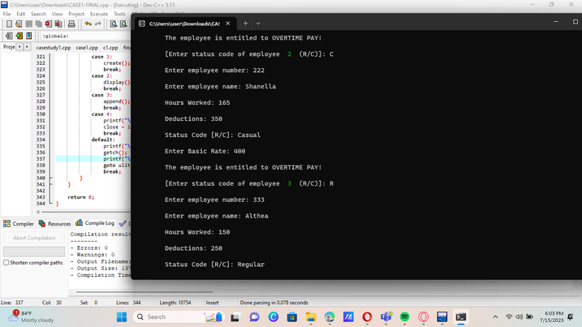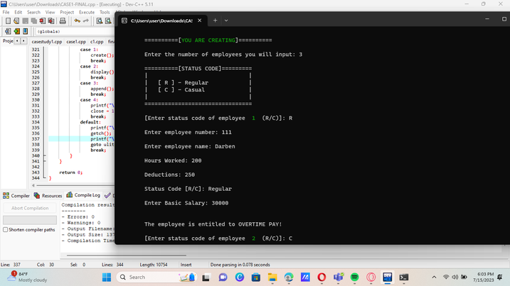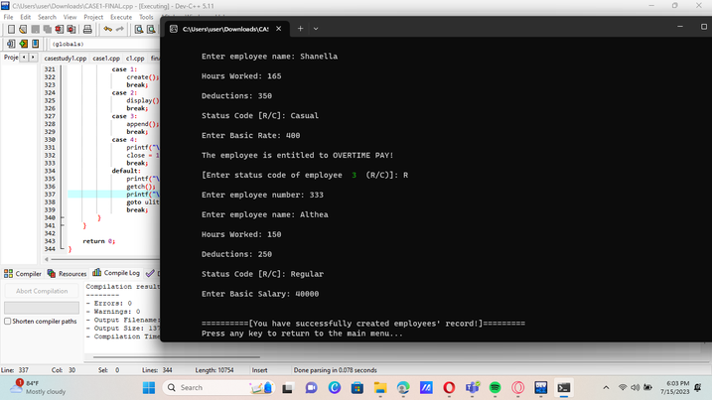

**DISPLAY**

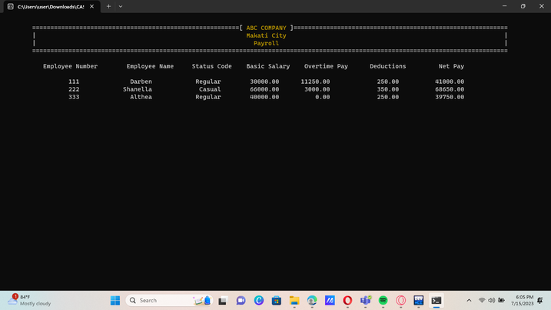

**APPEND**

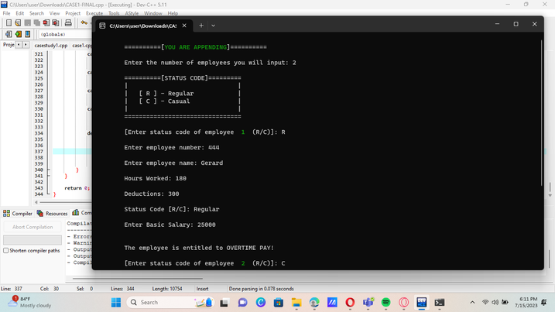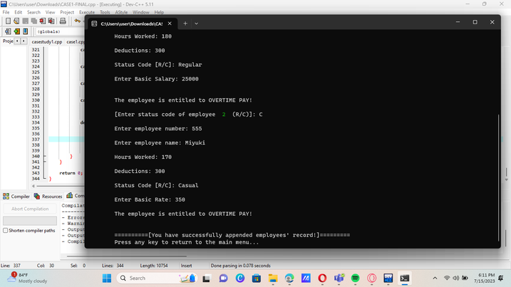

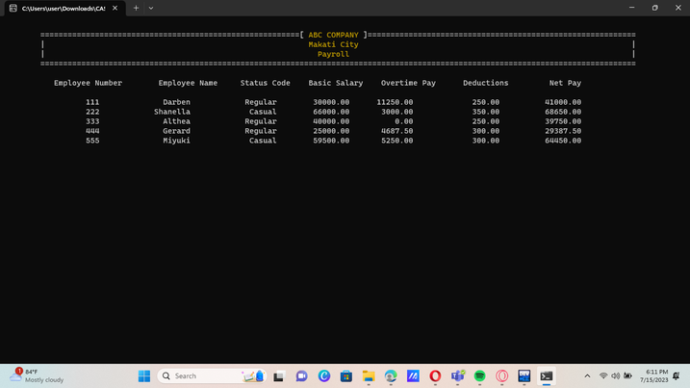

**[ERRORS ENCOUNTERED]**

**The program cannot be created, but when we try the same in a different device, the program is functioning.**

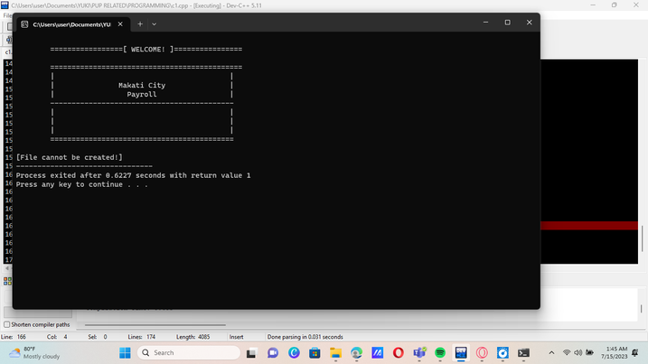

===========================***PROBLEM NUMBER 2:***==========================

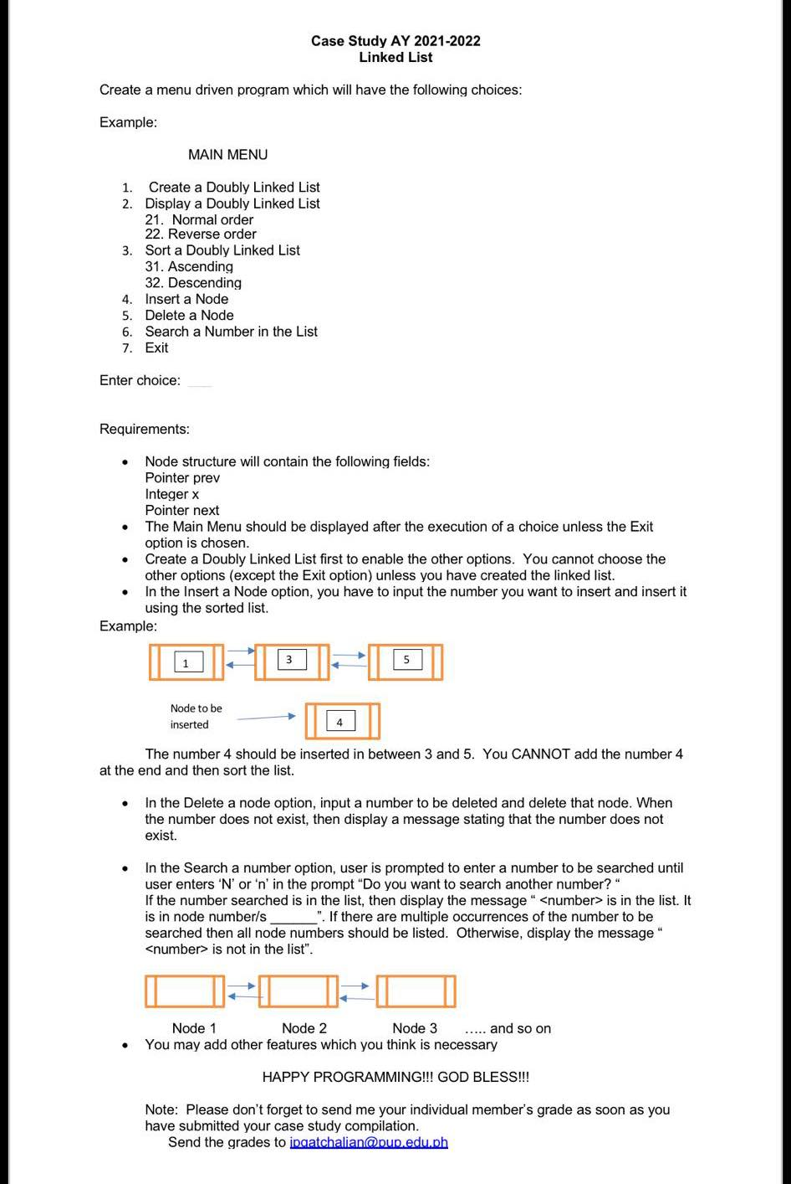

**PRINT OUTPUT:**



**FUNCTIONS:**

void create(); // function to create doubly linked list

void display(); //funtion to display the created linked list

void disnormal(); // function to display the linked list data in normal order

void disreverse(); // function to display the linked list data in normal order

void sort(); // function to sort the data in the created linked list

void ascend(); // function to sort the linked list data in ascending order

void descend(); // function to sort the linked list data in descending order

void insert(); // function to insert a new node

void dele(); // function to delete a node

void search(); // function to search a number in the created linked list

**CODE NO. 2**

***Code Link:*** <https://drive.google.com/file/d/1FbSoSoar5JMmz8l6604XOrCC7TKfWC_e/view?usp=drive_link>

**CODE EXPLANATION:**

These three header files are being included in the code. The stdio.h provides the input/output, the stdlib.h provides the memory allocation and the conio.h provides the console input and output.

#include <stdio.h>

#include <stdlib.h>

#include <conio.h>

Int choice is used to store the user’s menu choice. This also has a structure named node; it represents a node in a doubly linked list. The prev is used to point the previous node in the list

Int x is used as an integer variable to store the data of the node. The next pointer is used to point the next node in the list

int choice;

// structure definition

struct node {

struct node *prev;

int x;

struct node *next;

};

struct node *head, *curr, *tail; // structure declaration

**FUNCTIONS:**

// function prototyping

void create();

void display();

void disnormal();

void disreverse();

void sort();

void ascend();

void descend();

void insert();

void dele();

void search();

These functions perform various operations on the doubly linked list program. Such as creating, displaying in a normal order or disreverse order, sorting, inserting, deleting and searching.

int main () {

int close = 0; // initialize ng value for close para masatisfy yung condition below

while(close != 1) { // magrarun continously unless close = 1

menu:

system("cls");

printf("\t=========================================\n");

printf("\t| |\n");

printf("\t| MAIN MENU |\n");

printf("\t| |\n");

printf("\t=========================================\n");

printf("\t| |\n");

printf("\t| 1. Create a Doubly Linked List |\n");

printf("\t| 2. Display a Doubly Linked List |\n");

printf("\t| 3. Sort a Doubly Linked List |\n");

printf("\t| 4. Insert a Node |\n");

printf("\t| 5. Delete a Node |\n");

printf("\t| 6. Search a number in the list |\n");

printf("\t| 7. Exit |\n");

printf("\t| |\n");

printf("\t=========================================\n\n");

printf("\t [Enter choice]: ");

scanf("%d", &choice);

system("cls");

switch (choice) {

case 1:

create();

break;

case 2:

display();

break;

case 3:

sort();

break;

case 4:

insert();

break;

case 5:

dele();

break;

case 6:

search();

break;

case 7:

printf("\n\t[ Thank you for using our program! ]\n\n");

close = 1; // the program will exit

break;

default: printf("\n\n\t[ Invalid number! Choose 1-7 only. ]");

printf(" \n\n\tPress any key to continue...\n");

getch();

goto menu;

}

}

printf("\n\t=====< End of program >=====");

getch();

return 0;

}

This main function is used to execute the program. It displays the menu based on the choice of the user. It calls the different function to perform specific operations on the program. The program will keep running unless the user chooses to exit the program.

void create() {

head = curr = tail = NULL; // initialize the pointer to null

curr = (struct node *)malloc(sizeof(struct node)); // allocate the node

printf("\n\t=================[ OUTPUT ]================\n\n");

printf("\n\t-------------------------------------------\n");

printf("\tEnter a value for x [ 0 to terminate ]: ");

scanf("%d", &curr->x);

while(curr->x != 0) {

if(head == NULL) {

head = curr;

head->prev = NULL;

head->next = NULL;

tail = curr;

} else {

tail->next = curr;

curr->prev = tail;

curr->next = NULL;

tail = curr;

}

curr = (struct node *)malloc(sizeof(struct node));

printf("\tEnter a value for x [ 0 to terminate ]: ");

scanf("%d", &curr->x);

}

printf("\n\t-------------------------------------------\n");

printf("\n\t=====< End of program >=====");

printf("\n\tPress enter to return to main menu...");

getch();

}

void disnormal() {

if (head == NULL) {

return;

}

else {

printf("\n");

curr = head;

while (curr != NULL) {

printf("\t[ %d ] ", curr->x);

curr = curr->next;

}

}

}

void disreverse() {

if (head == NULL) {

return;

} else {

printf("\n");

curr = tail;

while (curr != NULL) {

printf("\t[ %d ] ", curr->x);

curr = curr->prev;

}

}

}

void display() {

int c;

int exit = 0;

while(exit == 0) {

system("cls");

printf("\n\t=========================[ OUTPUT ]==========================\n");

choice:

printf("\n\t=============================================================\n");

printf("\t| |\n");

printf("\t| How do you want your linked list data to be display? |\n");

printf("\t-------------------------------------------------------------\n");

printf("\t| |\n");

printf("\t| [ 1 ] Normal Order |\n");

printf("\t| [ 2 ] Reverse Order |\n");

printf("\t| [ 3 ] Exit |\n");

printf("\t| |\n");

printf("\t=============================================================\n");

printf("\n\t[ Enter your choice ]: ");

scanf("%d", &c);

system("cls");

switch (c) {

case 1:

printf("\n\t=========================================");

printf("\n\t| |");

printf("\n\t| Linked List Data in Normal Order: |");

printf("\n\t-----------------------------------------\n");

if (head == NULL) {

printf("\t| |\n");

printf("\t| [ Empty! ] |\n");

printf("\t| |\n");

printf("\t=========================================\n");

printf("\n\t<Create a doubly linked list first>");

printf("\n\tPress enter to continue...");

} else {

disnormal();

printf("\n\n\tPress enter to continue...");

getch();

}

break;

case 2:

printf("\n\t=========================================");

printf("\n\t| |");

printf("\n\t| Linked List Data in Reverse Order: |");

printf("\n\t-----------------------------------------\n");

if (head == NULL) {

printf("\t| |\n");

printf("\t| [ Empty! ] |\n");

printf("\t| |\n");

printf("\t=========================================\n");

printf("\n\t<Create a doubly linked list first>");

printf("\n\tPress enter to continue...");

} else {

disreverse();

printf("\n\n\tPress enter to continue...");

getch();

}

break;

case 3:

printf("\n\t=====< End of program >=====");

printf("\n\tPress enter to return to main menu...");

exit = 1;

break;

default:

printf("\n\n\t[ Invalid Input! ]\n");

printf("\n\tPlease enter 1-3 only! Press any key to continue...");

getch();

system("cls");

goto choice;

}

getch();

}

}

void ascend() {

int temp;

struct node *curr;

struct node *tail;

//Check whether list is empty

if(head == NULL) {

return;

}

else {

//Current will point to head

curr = head;

while(curr->next != NULL) {

//tail will point to node next to current

tail = curr->next;

while(tail != NULL) {

//If current's data is greater than tail's data, swap the data of current and tail

if(curr->x > tail->x) {

temp = curr->x;

curr->x = tail->x;

tail->x = temp;

}

tail = tail->next;

}

curr = curr->next;

}

}

disnormal();

}

void descend() {

int temp;

struct node *curr;

struct node *tail;

//Check whether list is empty

if(head == NULL) {

return;

}

else {

//Current will point to head

curr = head;

while(curr->next != NULL) {

// tail will point to node next to current

tail = curr->next;

while(tail != NULL) {

//If current's data is less than tail's data, swap the data of current and tail

if(curr->x < tail->x) {

temp = curr->x;

curr->x = tail->x;

tail->x = temp;

}

tail = tail->next;

}

curr = curr->next;

}

}

disnormal();

}

This display function is responsible for displaying the doubly linked list. It allows the user to choose what they want to display whether in normal or disreverse order.

void sort() {

int c;

int exit = 0;

while(exit == 0) {

system("cls");

printf("\n\t=========================[ OUTPUT ]==========================\n");

choice:

printf("\n\t=============================================================\n");

printf("\t| |\n");

printf("\t| How do you want your linked list data to be sorted? |\n");

printf("\t-------------------------------------------------------------\n");

printf("\t| |\n");

printf("\t| [ 1 ] Ascending Order |\n");

printf("\t| [ 2 ] Descending Order |\n");

printf("\t| [ 3 ] Exit |\n");

printf("\t| |\n");

printf("\t=============================================================\n");

printf("\n\t[ Enter choice ]: ");

scanf("%d", &c);

system("cls");

switch (c) {

case 1:

printf("\n\t=========================================");

printf("\n\t| |");

printf("\n\t| Linked List Data in Ascending Order: |");

printf("\n\t-----------------------------------------\n");

if (head == NULL) {

printf("\t| |\n");

printf("\t| [ Empty! ] |\n");

printf("\t| |\n");

printf("\t=========================================\n");

printf("\n\t--< Create a doubly linked list first >--");

}

else {

ascend();

printf("\n\n\tPress enter to continue...");

getch();

}

break;

case 2:

printf("\n\t===========================================");

printf("\n\t| |");

printf("\n\t| Linked List Data in Descending Order: |");

printf("\n\t-------------------------------------------\n");

if (head == NULL) {

printf("\t| |\n");

printf("\t| [ Empty! ] |\n");

printf("\t| |\n");

printf("\t===========================================\n");

printf("\n\t--< Create a doubly linked list first >--");

}

else {

descend();

printf("\n\n\tPress enter to continue...");

getch();

}

break;

case 3:

printf("\n\t=====< End of program >=====");

printf("\n\n\tPress enter to return to main menu...");

exit = 1;

break;

default:

printf("\n\n\t[ Invalid Input! ]\n");

printf("\n\tPlease enter 1-3 only! Press any key to continue...");

getch();

system("cls");

goto choice;

}

getch();

}

}

The doubly linked list must be sorted using the sort function. The user can select whether they want to sort the list in ascending or descending order using the choices provided. It uses the ascend or descend feature to order the list in accordance with the user's selection.

void insert() {

char deci; // decision

input:

system("cls");

printf("\n\t=================[ OUTPUT ]================\n");

printf("\n\t===========================================");

printf("\n\t| |");

printf("\n\t| Linked List Data: |");

printf("\n\t-------------------------------------------\n");

ascend();

// check if the list is empty

if(head == NULL) {

printf("\t| |\n");

printf("\t| [ Empty! ] |\n");

printf("\t| |\n");

printf("\t===========================================\n");

printf("\n\t--< Create a doubly linked list first >--");

printf("\n\tPress any key to continue...");

getch();

return;

}

// create a new node and assign the value

struct node *newnode = (struct node *)malloc(sizeof(struct node));

printf("\n\n\tEnter a value for new node: ");

scanf("%d", &newnode->x);

newnode->prev = NULL;

newnode->next = NULL;

if(newnode->x < head->x) { //check if the new node should be inserted at the beginning

newnode->next = head;

head->prev = newnode;

head = newnode;

}

else if(newnode->x > tail->x) { //check if the new node should be inserted at the end

newnode->prev = tail;

tail->next = newnode;

tail = newnode;

}

else { // insert the new node in the middle of the list

struct node *temp = head; // temp will point to head

while(temp->next != NULL && temp->next->x < newnode->x) { // temp pointer will move to the next node if true

temp = temp->next;

}

newnode->prev = temp; // newnode->prev will point to temp

newnode->next = temp->next; //newnode->next will point to the node next to temp

if(temp->next != NULL) {

temp->next->prev = newnode; // the node next to temp will point to new node

}

temp->next = newnode; // the new node will become the node next to temp

}

//printing of new linked list data after insertion

again:

system("cls");

printf("\n\t============[ After Insertion ]============\n");

printf("\n\t===========================================");

printf("\n\t| |");

printf("\n\t| New Linked List Data: |");

printf("\n\t-------------------------------------------\n");

disnormal();

printf("\n\n\tDo you want to insert another node? [ Y/N ]: ");

scanf(" %c", &deci);

switch (deci) {

case 'Y':

case 'y':

goto input;

break;

case 'N':

case 'n':

printf("\n\n\tPress enter to return to main menu...");

break;

default:

printf("\n\n\t[ Invalid Input ]\n\n\tPlease enter Y or N. Press enter to continue");

getch();

goto again;

}

getch();

}

A new node is inserted into the doubly linked list using the insert function. It asks the user to provide a value for the new node and, based on that value, determines whether the node should be added at the start, middle, or end of the list. In order to properly link the new node, it updates the appropriate pointers.

void dele() {

int numdel; // number to be deleted

char d; // decision

int exit = 0;

system("cls");

printf("\n\t=================[ OUTPUT ]================\n\n");

printf("\n\t===========================================");

printf("\n\t| |");

printf("\n\t| Linked List Data: |");

printf("\n\t-------------------------------------------\n");

ascend();

if (head == NULL) {

printf("\t| |\n");

printf("\t| [Empty!] |\n");

printf("\t| |\n");

printf("\t===========================================\n");

printf("\n\t--< Create a doubly linked list first >--");

printf("\n\tPress any key to continue...");

getch();

return;

}

do {

retry:

printf("\n\n\tEnter the number you want to delete: ");

scanf("%d", &numdel);

struct node *temp = head;

struct node *curr = NULL;

if (temp != NULL && temp->x == numdel) {

head = temp->next;

free(temp);

} else {

while (temp != NULL && temp->x != numdel) {

curr = temp;

temp = temp->next;

}

if (temp == NULL) {

printf("\n\t[ The number you enter is not in the list! ]");

goto choose;

}

curr->next = temp->next;

free(temp);

}

ulit:

system("cls");

printf("\n\t=============[ After Deletion ]============\n");

printf("\n\t===========================================");

printf("\n\t| |");

printf("\n\t| New Linked List Data: |");

printf("\n\t-------------------------------------------\n");

disnormal();

if (head == NULL) {

printf("\t| |\n");

printf("\t| [ Empty! ] |\n");

printf("\t| |\n");

printf("\t===========================================\n");

printf("\n\tPress any key to continue...");

getch();

return;

}

choose:

printf("\n\n\tDo you want to try again? [ Y/N ]: ");

scanf(" %c", &d);

switch (d) {

case 'Y':

case 'y':

goto retry;

break;

case 'N':

case 'n':

printf("\n\n\tPress enter to return to main menu...");

exit = 1;

break;

default:

printf("\n\n\t[ Invalid Input ]\n\n\tPlease enter Y or N. Press enter to continue");

getch();

goto ulit;

}

} while(exit != 1);

getch();

}

A node in the doubly linked list is removed using the dele function. It asks the user to provide a value that should be destroyed, looks for the node that has that value, and then deletes it. It deals with situations in which the node that needs to be deleted is at the start, middle, or end of the list.

void search() {

struct node *ptr; // a pointer that travel accross the nodes

int val; //value to be search

int posi; // position

char decide;

int found;

int exit;

int occur;

if(head == NULL) {

system("cls");

printf("\n\t=================[ OUTPUT ]================\n");

printf("\n\t===========================================");

printf("\n\t| |");

printf("\n\t| Linked List Data: |");

printf("\n\t-------------------------------------------\n");

printf("\t| |\n");

printf("\t| [ Empty! ] |\n");

printf("\t| |\n");

printf("\t===========================================\n");

printf("\n\t--< Create a doubly linked list first >--");

printf("\n\tPress any key to continue...");

getch();

return;

}

do {

retry:

system("cls");

posi = occur = found = exit = 0;

printf("\n\n\tEnter a value to be searched: ");

scanf("%d", &val);

ptr = head;

while(ptr != NULL) {

posi++;

if(ptr->x == val) {

printf("\n\t[%d is in the list! It is in the node number: %d]", val, posi);

found = 1;

occur++;

}

ptr = ptr->next;

}

printf("\n\n\t[There is/are %d occurrences of the number %d.]\n", occur, val);

if(found == 0) {

printf("\n\n\t[ %d is not in the list!]", val);

}

printf("\n\t============[ FOR CHECKING ]===============\n");

printf("\n\t===========================================");

printf("\n\t| |");

printf("\n\t| Linked List Data: |");

printf("\n\t-------------------------------------------\n");

disnormal();

isapa:

printf("\n\n\tDo you want to search another value? [ Y/N ]: ");

scanf(" %c", &decide);

switch (decide) {

case 'Y':

case 'y':

goto retry;

break;

case 'N':

case 'n':

printf("\n\n\tPress enter to return to main menu...");

exit = 1;

break;

default:

printf("\n\n\t[ Invalid Input ]\n\n\tPlease enter Y or N. Press enter to continue...");

getch();

goto isapa;

}

} while (exit != 1);

getch();

}

The doubly linked list can be searched for a value using the search function. It asks the user to enter a value to search for, iterates through the list to find every instance of the value, and then it displays where each instance is located.

**SAMPLE OUTPUT:**

**OUTPUT**

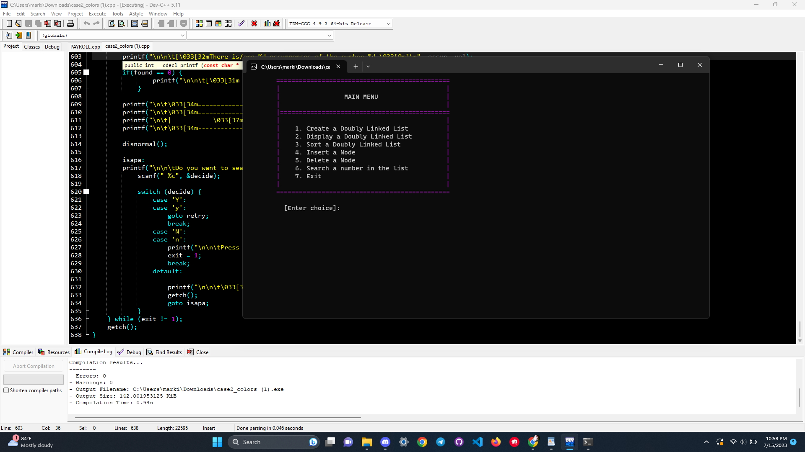

**[ERRORS ENCOUNTERED]**

**The program is spontaneously running and not going back to main**

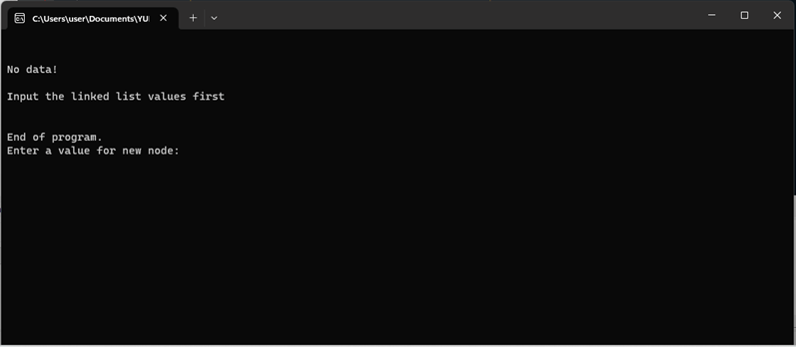

**The program terminates instantly.**

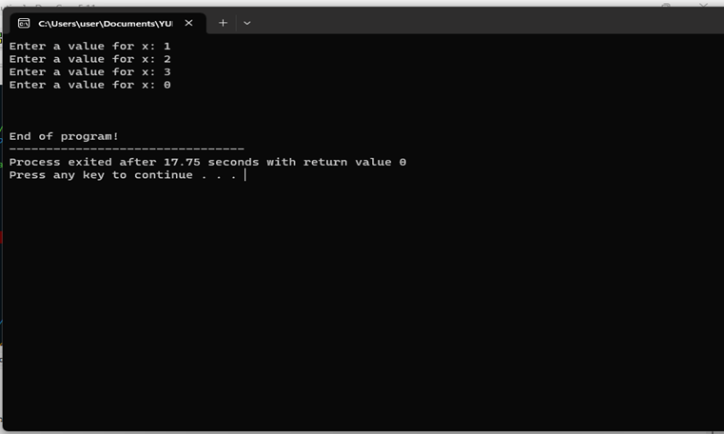

**When you are entering a letter in menu number 1 you will get this error.**

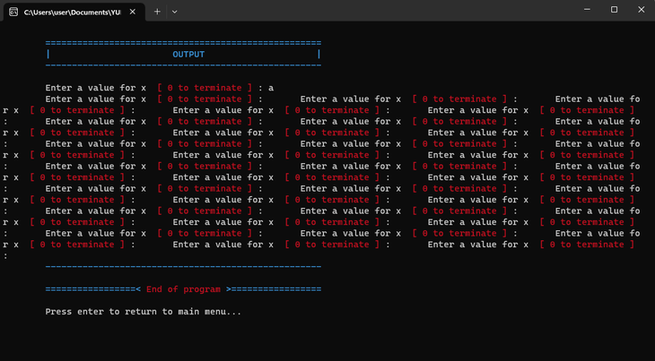

**When you are entering a letter in the search menu you will get this error.**

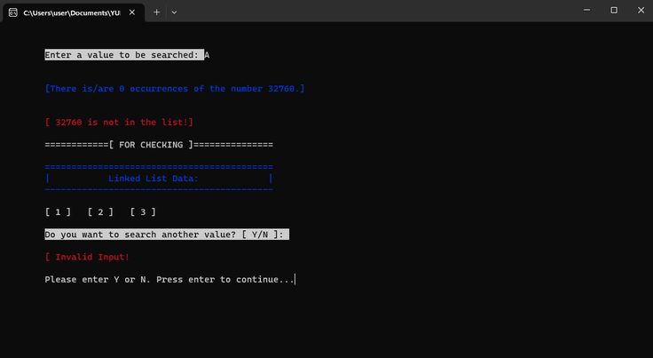

**CODE NO.1 (FINAL):**

#include <stdio.h>

#include <stdlib.h>

#include <string.h>

#include <conio.h>

#include <ctype.h>

int number, i;

FILE* fptr;

struct employee {

char empname[15];

char empnum[10];

char statcode[8];

int hrswork;

double bsalary;

double brate;

double halfbrate;

double otpay;

double othours;

double otrate;

double netpay;

double deduc;

};

struct employee emprec[100]; // Array to store employee records

int ValidName(const char* name) {

for (int i = 0; name[i] != '\0'; i++) {

if (isdigit(name[i])) {

return 0;

}

}

return 1;

}

void input() {

printf("\n\tEnter employee number: ");

scanf("%s", emprec[i].empnum);

again:

printf("\n\tEnter employee name: ");

scanf("\n");

scanf("%[^\n]s", emprec[i].empname);

int validName = 0;

if (!ValidName(emprec[i].empname)) {

printf("\n\tInvalid employee name!\n\tOnly alphabetic characters are allowed.\n");

goto again;

} else {

validName = 1; // allowing the program to move forward

}

printf("\n\tHours Worked: ");

scanf("%d", &emprec[i].hrswork);

printf("\n\tDeductions: ");

scanf("%lf", &emprec[i].deduc);

printf("\n\tStatus Code [R/C]: %s ", emprec[i].statcode);

}

void otcompu() {

emprec[i].halfbrate = emprec[i].brate / 2;

emprec[i].otrate = emprec[i].brate + emprec[i].halfbrate;

emprec[i].othours = emprec[i].hrswork - 160;

emprec[i].otpay = emprec[i].otrate * emprec[i].othours;

}

void regular() {

input();

printf("\n\n\tEnter Basic Salary: ");

scanf("%lf", &emprec[i].bsalary);

if (emprec[i].hrswork > 160) {

printf("\n\n\tThe employee is entitled to OVERTIME PAY!\n");

emprec[i].brate = emprec[i].bsalary / 160;

otcompu();

}

}

void casual() {

input();

printf("\n\n\tEnter Basic Rate: ");

scanf("%lf", &emprec[i].brate);

emprec[i].bsalary = emprec[i].brate * emprec[i].hrswork;

if (emprec[i].hrswork > 160) {

printf("\n\tThe employee is entitled to OVERTIME PAY!\n");

otcompu();

}

}

void create() {

char sc;

int ex;

fptr = fopen("employ.txt", "w"); // Open file in write mode

system("cls");

if (fptr == NULL) {

printf("\n\t[File cannot be created!]");

exit(1);

}

do {

printf("\n\t==========[\033[32mYOU ARE CREATING\033[0m]==========\n");

printf("\n\tEnter the number of employees you will input: ");

scanf("%d", &number);

if (number <= 0) {

printf("\n\tInvalid input! Please enter a positive number.\n");

fflush(stdin);

}

} while (number <= 0);

printf("\n\t==========[STATUS CODE]=========");

printf("\n\t| |");

printf("\n\t| [ R ] - Regular |");

printf("\n\t| [ C ] - Casual |");

printf("\n\t| |");

printf("\n\t================================\n");

fprintf(fptr, "\n\t\tABC COMPANY\n");

fprintf(fptr, "\t\tMakati City\n");

fprintf(fptr, "\n\t\tPayroll\n\n");

fprintf(fptr, "\n\t %15s\t%15s\t%15s\t%15s\t%15s\t%15s\t%15s \n", "Employee Number", "Employee Name", "Status Code", "Basic Salary", "Overtime Pay", "Deductions", "Net Pay" );

for (i = 0; i < number; i++) {

ex = 0;

while (ex == 0) {

again:

printf("\n\t[Enter status code of employee \033[32m %d \033[0m (R/C)]: ", i + 1);

scanf(" %c", &sc);

switch (sc) {

case 'R':

case 'r':

strcpy(emprec[i].statcode, "Regular");

regular();

ex = 1;

break;

case 'C':

case 'c':

strcpy(emprec[i].statcode, "Casual");

casual();

ex = 1;

break;

default:

printf("\n\t[Invalid Input!]\n\tEnter R or C only! Press any key to continue...");

getch();

printf("\n");

goto again;

break;

}

}

emprec[i].netpay = emprec[i].bsalary + emprec[i].otpay - emprec[i].deduc;

fprintf(fptr, "\n\t%13s\t%17s\t%12s\t%12.2lf\t%10.2lf\t%13.2lf\t%15.2lf", emprec[i].empnum, emprec[i].empname, emprec[i].statcode, emprec[i].bsalary, emprec[i].otpay, emprec[i].deduc, emprec[i].netpay);

}

fclose(fptr); // Close the file

printf("\n\n\t==========[You have successfully created employees' record!]=========");

printf("\n\tPress any key to return to the main menu...");

getch();

return;

}

void display() {

fptr = fopen("employ.txt", "r"); // Open file in read mode

system("cls");

if (fptr == NULL) {

printf("\n\t[File does not exist!]");

exit(1);

}

printf("\n\t=========================================================[ \033[33mABC COMPANY\033[0m ]===========================================================");

printf("\n\t| \033[33mMakati City\033[0m |");

printf("\n\t| \033[33mPayroll\033[0m |");

printf("\n\t===================================================================================================================================\n");

char line[150];

int skipLines = 6; // Number of lines to skip before printing employee records

while (fgets(line, sizeof(line), fptr) != NULL) {

// Skip the lines containing ABC COMPANY, Makati City, and Payroll

if (skipLines > 0) {

skipLines--;

continue;

}

// Trim leading and trailing whitespace

char* trimmedLine = line;

size_t len = strlen(trimmedLine);

if (len > 0 && trimmedLine[len - 1] == '\n') {

trimmedLine[len - 1] = '\0';

}

// Print employee records

printf("%s\n", trimmedLine);

}

fclose(fptr); // Close the file

getch();

return;

}

void append() {

char sc;

int ex;

fptr = fopen("employ.txt", "a"); // Open file in append mode

system("cls");

if (fptr == NULL) {

printf("\n\t[File cannot be created!]");

exit(1);

}

printf("\n\t==========[\033[32mYOU ARE APPENDING\033[0m]==========\n");

do {

printf("\n\tEnter the number of employees you will input: ");

scanf("%d", &number);

if (number <= 0) {

printf("\n\tInvalid input! Please enter a positive number.\n");

fflush(stdin);

}

} while (number <= 0);

printf("\n\t==========[STATUS CODE]=========");

printf("\n\t| |");

printf("\n\t| [ R ] - Regular |");

printf("\n\t| [ C ] - Casual |");

printf("\n\t| |");

printf("\n\t================================\n");

for (i = 0; i < number; i++) {

ex = 0;

while (ex == 0) {

again:

printf("\n\t[Enter status code of employee \033[32m %d \033[0m (R/C)]: ", i + 1);

scanf(" %c", &sc);

switch (sc) {

case 'R':

case 'r':

strcpy(emprec[i].statcode, "Regular");

regular();

ex = 1;

break;

case 'C':

case 'c':

strcpy(emprec[i].statcode, "Casual");

casual();

ex = 1;

break;

default:

printf("\n\t[Invalid Input!]\n\tEnter R or C only! Press any key to continue...");

getch();

goto again;

break;

}

}

emprec[i].netpay = emprec[i].bsalary + emprec[i].otpay - emprec[i].deduc;

fprintf(fptr, "\n\t%13s\t%17s\t%12s\t%12.2lf\t%10.2lf\t%13.2lf\t%15.2lf", emprec[i].empnum, emprec[i].empname, emprec[i].statcode, emprec[i].bsalary, emprec[i].otpay, emprec[i].deduc, emprec[i].netpay);

}

fclose(fptr); // Close the file

printf("\n\n\t==========[You have successfully appended employees' record!]=========");

printf("\n\tPress any key to return to the main menu...");

getch();

return;

}

int main() {

int choice;

int close;

close = 0;

while (close == 0) {

system("cls");

printf("\n\t\033[36m=================[\033[37mWELCOME!\033[36m]================\033[0m\n");

printf("\n\t\033[36m=============================================\033[0m");

printf("\n\t\033[36m| |\033[0m");

printf("\n\t\033[36m| \033[37m [ 1 ] Create \033[36m |\033[0m");

printf("\n\t\033[36m| \033[37m [ 2 ] Display \033[36m |\033[0m");

printf("\n\t\033[36m| \033[37m [ 3 ] Append \033[36m |\033[0m");

printf("\n\t\033[36m| \033[37m [ 4 ] Exit \033[36m |\033[0m");

printf("\n\t\033[36m| |\033[0m");

printf("\n\t\033[36m=============================================\033[0m\n");

ulitpar:

printf("\n\tEnter your choice: ");

scanf("%d", &choice);

switch (choice) {

case 1:

create(); // Create employee records

break;

case 2:

display(); // Display employee records

break;

case 3:

append(); // Append employee records

break;

case 4:

printf("\n\tEnd of Program...");

close = 1; // Exit the program

break;

default:

printf("\n\tPlease enter 1-4 only! Press any key to continue...");

getch();

printf("\n");

goto ulitpar;

break;

}

}

return 0;

}

**CODE NO. 2 (FINAL):**

#include <stdio.h>

#include <stdlib.h>

#include <conio.h>

int choice;

// structure definition

struct node {

struct node *prev;

int x;

struct node *next;

};

struct node *head, *curr, *tail; // structure declaration

// function prototyping

void create();

void display();

void disnormal();

void disreverse();

void sort();

void ascend();

void descend();

void insert();

void dele();

void search();

int main () {

int close = 0; // initialize ng value for close para masatisfy yung condition below

while(close != 1) { // magrarun continously unless close = 1

menu:

system("cls");

printf("\t\033[35m==============================================\033[0m\n");

printf("\t\033[35m| |\033[0m\n");

printf("\t\033[35m| \033[37mMAIN MENU \033[35m|\n");

printf("\t\033[35m| |\033[0m\n");

printf("\t\033[35m|=============================================\033[0m\n");

printf("\t\033[35m| |\033[0m\n");

printf("\t\033[35m| \033[37m1. Create a Doubly Linked List \033[35m|\n");

printf("\t\033[35m| \033[37m2. Display a Doubly Linked List \033[35m|\n");

printf("\t\033[35m| \033[37m3. Sort a Doubly Linked List \033[35m|\n");

printf("\t\033[35m| \033[37m4. Insert a Node \033[35m|\n");

printf("\t\033[35m| \033[37m5. Delete a Node \033[35m|\n");

printf("\t\033[35m| \033[37m6. Search a number in the list \033[35m|\n");

printf("\t\033[35m| \033[37m7. Exit \033[35m|\n");

printf("\t\033[35m| |\033[0m\n");

printf("\t\033[35m==============================================\033[0m\n\n");

printf("\t [Enter choice]: ");

scanf("%d", &choice);

system("cls");

switch (choice) {

case 1:

create();

break;

case 2:

display();

break;

case 3:

sort();

break;

case 4:

insert();

break;

case 5:

dele();

break;

case 6:

search();

break;

case 7:

printf("\n\t[ Thank you for using our program! ]\n\n");

close = 1; // the program will exit

break;

default: printf("\n\n\t[ \033[31mInvalid number! Choose 1-7 only. \033[0m]");

printf(" \n\n\tPress any key to continue...");

getch();

goto menu;

}

}

printf("\n\t=========< \033[31mEnd of program \033[0m>=========");

getch();

return 0;

}

void create() {

head = curr = tail = NULL; // initialize the pointer to null

curr = (struct node *)malloc(sizeof(struct node)); // allocate the node

printf("\n\t\033[36m====================================================\033[0m");

printf("\n\t\033[36m| \033[37mOUTPUT \033[36m|\033[0m");

printf("\n\t\033[36m----------------------------------------------------\033[0m\n\n");

printf("\tEnter a value for x \033[33m [ 0 to terminate ]\033[0m : ");

scanf("%d", &curr->x);

while(curr->x != 0) {

if(head == NULL) {

head = curr;

head->prev = NULL;

head->next = NULL;

tail = curr;

} else {

tail->next = curr;

curr->prev = tail;

curr->next = NULL;

tail = curr;

}

curr = (struct node *)malloc(sizeof(struct node));

printf("\tEnter a value for x \033[33m [ 0 to terminate ]\033[0m : ");

scanf("%d", &curr->x);

}

printf("\n\t\033[36m----------------------------------------------------\033[0m\n");

printf("\n\t=================<\033[31m End of program \033[0m>=================\n");

printf("\n\tPress enter to return to main menu...");

getch();

}

void disnormal() {

if (head == NULL) {

return;

}

else {

printf("\n");

curr = head;

while (curr != NULL) {

printf("\t[ %d ] ", curr->x);

curr = curr->next;

}

}

}

void disreverse() {

if (head == NULL) {

return;

} else {

printf("\n");

curr = tail;

while (curr != NULL) {

printf("\t[ %d ] ", curr->x);

curr = curr->prev;

}

}

}

void display() {

int c;

int exit = 0;

while(exit == 0) {

system("cls");

printf("\n\t\033[32m=============================================================\033[0m");

printf("\n\t\033[32m| \033[37mOUTPUT \033[32m|\033[0m");

choice:

printf("\n\t\033[32m|===========================================================|\n");

printf("\t\033[32m| \033[37mHow do you want your linked list data to be display? \033[32m|\033[0m\n");

printf("\t\033[32m|-----------------------------------------------------------\033[32m|\033[0m\n");

printf("\t\033[32m| \033[32m|\033[0m\n");

printf("\t\033[32m|\033[0m [ 1 ] Normal Order \033[32m|\033[0m\n");

printf("\t\033[32m|\033[0m [ 2 ] Reverse Order \033[32m|\033[0m\n");

printf("\t\033[32m|\033[0m [ 3 ] Exit \033[32m|\033[0m\n");

printf("\t\033[32m| \033[32m|\033[0m\n");

printf("\t\033[32m=============================================================\033[0m\n");

printf("\n\t[ Enter your choice ]: ");

scanf("%d", &c);

system("cls");

switch (c) {

case 1:

printf("\n\t\033[32m==============================================");

printf("\n\t\033[32m| \033[0mLinked List Data in Normal Order: \033[32m|");

printf("\n\t\033[32m==============================================\033[0m\n");

if (head == NULL) {

printf("\t\033[32m| |\n");

printf("\t\033[32m| \033[31m[ Empty! ] \033[32m|\n");

printf("\t\033[32m| |\n");

printf("\t\033[32m==============================================\033[0m\n");

printf("\n\t=====< \033[31mCreate a doubly linked list first\033[0m >=====\n");

printf("\n\tPress enter to continue...");

} else {

disnormal();

printf("\n\n\tPress enter to continue...");

getch();

}

break;

case 2:

printf("\n\t\033[32m==============================================");

printf("\n\t\033[32m| \033[0mLinked List Data in Reverse Order: \033[32m|");

printf("\n\t\033[32m==============================================\033[0m\n");

if (head == NULL) {

printf("\t\033[32m| |\n");

printf("\t\033[32m| \033[31m[ Empty! ] \033[32m|\n");

printf("\t\033[32m| |\n");

printf("\t\033[32m==============================================\033[0m\n");

printf("\n\t=====< \033[31mCreate a doubly linked list first\033[0m >=====\n");

printf("\n\tPress enter to continue...");

} else {

disreverse();

printf("\n\n\tPress enter to continue...");

getch();

}

break;

case 3:

printf("\n\t========< \033[31mEnd of program \033[37m>========\033[0m\n\n");

printf("\n\tPress enter to return to main menu...");

exit = 1;

break;

default:

printf("\n\n\t[\033[31m Invalid Input! \033[37m]\033[0m\n");

printf("\n\tPlease enter 1-3 only! Press any key to continue...");

getch();

system("cls");

goto choice;

}

getch();

}

}

void ascend() {

int temp;

struct node *curr;

struct node *tail;

//Check whether list is empty

if(head == NULL) {

return;

}

else {

//Current will point to head

curr = head;

while(curr->next != NULL) {

//tail will point to node next to current

tail = curr->next;

while(tail != NULL) {

//If current's data is greater than tail's data, swap the data of current and tail

if(curr->x > tail->x) {

temp = curr->x;

curr->x = tail->x;

tail->x = temp;

}

tail = tail->next;

}

curr = curr->next;

}

}

disnormal();

}

void descend() {

int temp;

struct node *curr;

struct node *tail;

//Check whether list is empty

if(head == NULL) {

return;

}

else {

//Current will point to head

curr = head;

while(curr->next != NULL) {

// tail will point to node next to current

tail = curr->next;

while(tail != NULL) {

//If current's data is less than tail's data, swap the data of current and tail

if(curr->x < tail->x) {

temp = curr->x;

curr->x = tail->x;

tail->x = temp;

}

tail = tail->next;

}

curr = curr->next;

}

}

disnormal();

}

void sort() {

int c;

int exit = 0;

while(exit == 0) {

system("cls");

printf("\n\t\033[36m=============================================================\033[0m");

printf("\n\t\033[36m| \033[37mOUTPUT \033[36m|\033[0m");

choice:

printf("\n\t\033[36m|===========================================================|\033[0m\n");

printf("\t\033[36m| \033[37mHow do you want your linked list data to be sorted? \033[36m|\n");

printf("\t\033[36m|-----------------------------------------------------------\033[36m|\n");

printf("\t\033[36m| \033[36m|\n");

printf("\t\033[36m| \033[37m[ 1 ] Ascending Order \033[36m|\n");

printf("\t\033[36m| \033[37m[ 2 ] Descending Order \033[36m|\n");

printf("\t\033[36m| \033[37m[ 3 ] Exit \033[36m|\n");

printf("\t\033[36m| \033[36m|\n");

printf("\033[36m\t=============================================================\033[0m\n");

printf("\n\t[ Enter choice ]: ");

scanf("%d", &c);

system("cls");

switch (c) {

case 1:

printf("\n\t\033[35m===================================================");

printf("\n\t\033[35m| \033[37mLinked List Data in Ascending Order: \033[35m|");

printf("\n\t\033[35m|-------------------------------------------------|\033[0m\n");

if (head == NULL) {

printf("\t\033[35m| |\n");

printf("\t\033[35m| \033[31m[ Empty! ] \033[35m|\033[0m\n");

printf("\t\033[35m| |\n");

printf("\t\033[35m===================================================\033[0m\n");

printf("\n\t===< \033[31mCreate a doubly linked list first\033[0m >====\n");

printf("\n\tPress enter to continue...");

}

else {

ascend();

printf("\n\n\tPress enter to continue...");

getch();

}

break;

case 2:

printf("\n\t\033[35m===================================================");

printf("\n\t\033[35m| \033[37mLinked List Data in Descending Order: \033[35m|");

printf("\n\t\033[35m|-------------------------------------------------|\033[0m\n");

if (head == NULL) {

printf("\t\033[35m| |\n");

printf("\t\033[35m| \033[31m[ Empty! ] \033[35m|\033[0m\n");

printf("\t\033[35m| |\n");

printf("\t\033[35m===================================================\033[0m\n");

printf("\n\t===< \033[31mCreate a doubly linked list first\033[0m >====\n");

printf("\n\tPress enter to continue...");

}

else {

descend();

printf("\n\n\tPress enter to continue...");

getch();

}

break;

case 3:

printf("\n\t========< \033[31mEnd of program \033[37m>========\033[0m\n\n");

printf("\n\tPress enter to return to main menu...");

exit = 1;

break;

default:

printf("\n\n\t\033[0m[\033[31m Invalid Input! \033[37m]\033[0m\n");

printf("\n\tPlease enter 1-3 only! Press any key to continue...");

getch();

system("cls");

goto choice;

}

getch();

}

}

void insert() {

char deci; // decision

input:

system("cls");

printf("\n\t\033[32m=========================================\033[0m");

printf("\n\t\033[32m| \033[37mOUTPUT \033[32m|\033[0m");

printf("\n\t\033[32m|=======================================|\033[0m\n");

printf("\t\033[32m| \033[37mLinked List Data: \033[32m|\n");

printf("\t\033[32m|=======================================|\033[0m\n");

ascend();

// check if the list is empty

if(head == NULL) {

printf("\t\033[32m| |\n");

printf("\t\033[32m| \033[31m[ Empty! ] \033[32m|\n");

printf("\t\033[32m| |\n");

printf("\t\033[32m=========================================\033[0m\n");

printf("\n\t=====< \033[31mCreate a doubly linked list first\033[0m >=====\n");

printf("\n\tPress any key to continue...");

getch();

return;

}

// create a new node and assign the value

struct node *newnode = (struct node *)malloc(sizeof(struct node));

printf("\n\n\t\033[33mEnter a value for new node: \033[0m");

scanf("%d", &newnode->x);

newnode->prev = NULL;

newnode->next = NULL;

if(newnode->x < head->x) { //check if the new node should be inserted at the beginning

newnode->next = head;

head->prev = newnode;

head = newnode;

}

else if(newnode->x > tail->x) { //check if the new node should be inserted at the end

newnode->prev = tail;

tail->next = newnode;

tail = newnode;

}

else { // insert the new node in the middle of the list

struct node *temp = head; // temp will point to head

while(temp->next != NULL && temp->next->x < newnode->x) { // temp pointer will move to the next node if true

temp = temp->next;

}

newnode->prev = temp; // newnode->prev will point to temp

newnode->next = temp->next; //newnode->next will point to the node next to temp

if(temp->next != NULL) {

temp->next->prev = newnode; // the node next to temp will point to new node

}

temp->next = newnode; // the new node will become the node next to temp

}

//printing of new linked list data after insertion

again:

system("cls");

printf("\n\t\033[35m============\033[37m[ After Insertion ]\033[35m============\n");

printf("\n\t\033[35m===========================================");

printf("\n\t\033[35m| \033[37mNew Linked List Data: \033[35m|");

printf("\n\t\033[35m-------------------------------------------\033[0m\n");

disnormal();

printf("\n\n\tDo you want to insert another node? [ Y/N ]: ");

scanf(" %c", &deci);

switch (deci) {

case 'Y':

case 'y':

goto input;

break;

case 'N':

case 'n':

printf("\n\n\tPress enter to return to main menu...");

break;

default:

printf("\n\n\t\033[32m[\033[31m Invalid Input \033[32m]\n\n\t\033[37mPlease enter Y or N. Press enter to continue\033[0m");

getch();

goto again;

}

getch();

}

void dele() {

int numdel; // number to be deleted

char d; // decision

int exit = 0;

system("cls");

printf("\n\t\033[32m=========================================\033[0m");

printf("\n\t\033[32m| \033[37mOUTPUT \033[32m|\033[0m");

printf("\n\t\033[32m|=======================================|\033[0m\n");

printf("\t\033[32m| \033[37mLinked List Data: \033[32m|\n");

printf("\t\033[32m|=======================================|\033[0m\n");

ascend();

if (head == NULL) {

printf("\t\033[32m| |\n");

printf("\t\033[32m| \033[31m[ Empty! ] \033[32m|\n");

printf("\t\033[32m| |\n");

printf("\t\033[32m=========================================\033[0m\n");

printf("\n\t=====< \033[31mCreate a doubly linked list first\033[0m >=====\n");

printf("\n\tPress any key to continue...");

getch();

return;

}

do {

retry:

printf("\n\n\tEnter the number you want to delete: ");

scanf("%d", &numdel);

struct node *temp = head;

struct node *curr = NULL;

if (temp != NULL && temp->x == numdel) {

head = temp->next;

delete(temp);

} else {

while (temp != NULL && temp->x != numdel) {

curr = temp;

temp = temp->next;

}

if (temp == NULL) {

printf("\n\t[\033[31mThe number you enter is not in the list!\033[0m]");

goto choose;

}

curr->next = temp->next;

delete(temp);

}

ulit:

system("cls");

printf("\n\t\033[32m=============\033[37m[ After Deletion ]\033[32m============\n");

printf("\n\t\033[32m===========================================");

printf("\n\t\033[32m| \033[37mNew Linked List Data: \033[32m|");

printf("\n\t\033[32m-------------------------------------------\033[0m");

disnormal();

if (head == NULL) {

printf("\t| |\n");

printf("\t\033[31m| [ Empty! ] \033[31m|\n");

printf("\t| |\n");

printf("\t===========================================\n");

printf("\n\tPress any key to continue...");

getch();

return;

}

choose:

printf("\n\n\tDo you want to try again? [ Y/N ]: ");

scanf(" %c", &d);

switch (d) {

case 'Y':

case 'y':

goto retry;

break;

case 'N':

case 'n':

printf("\n\n\tPress enter to return to main menu...");

exit = 1;

break;

default:

printf("\n\n\t[ \033[31mInvalid Input \033[0m]\n\n\tPlease enter Y or N. Press enter to continue");

getch();

goto ulit;

}

} while(exit != 1);

getch();

}

void search() {

struct node *ptr; // a pointer that travel accross the nodes

int val; //value to be search

int posi; // position

char decide;

int found;

int exit;

int occur;

if(head == NULL) {

system("cls");

printf("\n\t\033[34m=========================================\033[0m");

printf("\n\t\033[34m| \033[37mOUTPUT \033[34m|\033[0m");

printf("\n\t\033[34m|=======================================|\033[0m\n");

printf("\t\033[34m| \033[37mLinked List Data: \033[34m|\n");

printf("\t\033[34m|=======================================|\033[0m\n");

printf("\t\033[34m| |\n");

printf("\t\033[34m| \033[31m[ Empty! ] \033[34m|\n");

printf("\t\033[34m| |\n");

printf("\t\033[34m=========================================\033[0m\n");

printf("\n\t===< \033[31mCreate a doubly linked list first\033[0m >===\n");

printf("\n\tPress any key to continue...");

getch();

return;

}

do {

retry:

system("cls");

posi = occur = found = exit = 0;

printf("\n\n\tEnter a value to be searched: \033[0m");

scanf("%d", &val);

ptr = head;

while(ptr != NULL) {

posi++;

if(ptr->x == val) {

printf("\n\t[%d is in the list! It is in the node number: %d]", val, posi);

found = 1;

occur++;

}

ptr = ptr->next;

}

printf("\n\n\t[\033[32mThere is/are %d occurrences of the number %d.\033[0m]\n", occur, val);

if(found == 0) {

printf("\n\n\t[\033[31m %d is not in the list!\033[0m]\n", val);

}

printf("\n\t\033[34m============\033[37m[ FOR CHECKING ]\033[34m===============\033[0m\n");

printf("\n\t\033[34m===========================================");

printf("\n\t| \033[37mLinked List Data: \033[34m|");

printf("\n\t\033[34m-------------------------------------------\033[0m\n");

disnormal();

isapa:

printf("\n\n\tDo you want to search another value? [ Y/N ]: ");

scanf(" %c", &decide);

switch (decide) {

case 'Y':

case 'y':

goto retry;

break;

case 'N':

case 'n':

printf("\n\n\tPress enter to return to main menu...");

exit = 1;

break;

default:

printf("\n\n\t\033[31m[ Invalid Input! ]\033[0m\n\n\tPlease enter Y or N. Press enter to continue...");

getch();

goto isapa;

}

} while (exit != 1);

getch();

}

**RUBRICS:**

